**OBJECT ORIENTED PROGRAMMING**

LAB 5

PACKAGES

NAME: VASUGI M

ROLLNO: 21ADRO57

1. Write a Java program to perform employee payroll processing using packages.

In the java file, Emp.java creates a package employee and creates a class Emp.

Declare the variables name, empid, category, bpay, hra, da, npay, pf, grosspay, incometax,

and allowance.

Use parameterized constructor to initialize the variables such as name, empid, category,

bpay.

Use calculate () methods to calculate the following values.

da=bpay*0.05;

hra=bpay*0.09;

pf=bpay*0.11;

allowance=bpay*0.10;

grosspay=bpay+da+hra+allowance-pf;

incometax=0.75*grosspay;

npay = grosspay- incometax;

Use disp () method to display the complete employee details.

Create another java file “Emppay.java” outside of the above package. Create a necessary

object to access the methods and constructors in above package.

**CODE:**

**Emp.java**

package employee;

public class Emp{

String name,empid, category;

int bpay;

double hra,da,npay,pf,grosspay,incometax,allowance;

public Emp(String n, String id, String c, int b)

{

name = n;

empid = id;

category = c;

bpay = b;

}

public void call()

{

da = bpay*0.05;

hra = bpay*0.09;

pf = bpay*0.11;

allowance = bpay*0.10;

grosspay = bpay+da+hra+allowance-pf;

incometax = 0.75*grosspay;

npay = grosspay- incometax;

}

public void display()

{

System.out.println("/n/n Employee Details");

System.out.println("/n/n Name:"+name);

System.out.println("/n/n Empid:"+empid);

System.out.println("/n/n Category:"+category);

System.out.println("/n/n bpay:"+bpay);

System.out.println("/n/n da:"+da);

System.out.println("/n/n hra:"+hra);

System.out.println("/n/n pf:"+pf);

System.out.println("/n/n all:"+allowance);

System.out.println("/n/n gs:"+grosspay);

System.out.println("/n/n Incometax:"+incometax);

System.out.println("/n/n npay:"+npay);

}}

**MAIN FILE:**

Emppay.java

package employee;

import java.io.*;

import employee.*;

public class Emppay

{

public static void main (String args[])

{

Emp e = new Emp("ANU","23","Female",12000);

e.call();

e.display();

}

}

**OUTPUT:**

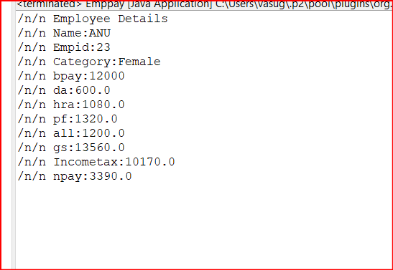

2. Provide the java code to demonstrate the below diagram

Calculator Package

**CODE:**

**ADDITION.JAVA**

package calculate;

import java.io.*;

import java.util.*;

public class Addition {

public void Add() {

Scanner sc = new Scanner(System.in);

int a = sc.nextInt();

int b = sc.nextInt();

int c = a+b;

System.out.print("Sum of Two numbers = "+c);

}}

**SUBTRACTION.JAVA**

package calculate;

import java.io.*;

import java.util.*;

public class Subtraction {

public void Sub() {

Scanner sc = new Scanner(System.in);

int a = sc.nextInt();

int b = sc.nextInt();

int c = a-b;

System.out.print("Difference of Two numbers = "+c);

}

}

**MULTIPLY.JAVA**

package calculate;

import java.io.*;

import java.util.*;

public class Multi {

public void Mul() {

Scanner sc = new Scanner(System.in);

int a = sc.nextInt();

int b = sc.nextInt();

int c = a*b;

System.out.print("Product of Two numbers = "+c);

}}

**MAIN.JAVA**

package calculate;

public class Main {

public static void main(String[] args) {

Addition a1 = new Addition();

a1.Add();

Subtraction a2 = new Subtraction();

a2.Sub();

Multi a3 = new Multi();

a3.Mul();

}}

**OUTPUT:**

